PD Session 2: General Laboratory Safety Workshop
Speaker: Ellen Elsbern, Chief OSHA (Occupational Safety and Health Administration) Compliance Officer
Date: June 14, 2017
Time: 2:45pm-3:45pm
Venue: University of Cincinnati, Swift Hall, Room 516
Prepared by:
Kimberly Lykens, Stebbins High School, Dayton, Ohio
RET Participant for Project #1: “Synthesis and Characterization on Different Forms of Cu Nanoparticles to Mitigate Cu Leaching to Water Bodies”

This hazardous communication training was given by Ms. Elsbern, the Chief OSHA (Occupational Safety and Health Administration) Compliance Officer for the Office of Environmental Health and Safety at the University of Cincinnati. This training was held on June 14, 2017 from 2:45pm-3:45pm at the University of Cincinnati in Swift Hall (room 516).

Ms. Elsbern began her session by asking all participants to share their assigned research project and laboratory in which they will be working during their RET experience. This information was used throughout the safety presentation to make material more relevant and meaningful to individual teacher participants. Ms. Elsbern also took time to introduce her professional accomplishments and career path that led to her position as chief OSHA compliance officer at the University of Cincinnati. Ms. Elsbern has two undergraduate degrees in Science Education and Forensic Chemistry, an MBA in Operations Management, and has been working with laboratory safety efforts at the University of Cincinnati for twenty-one years. In addition to safety and health efforts on campus, Ms. Elsbern taught high school chemistry prior to her career with the university.

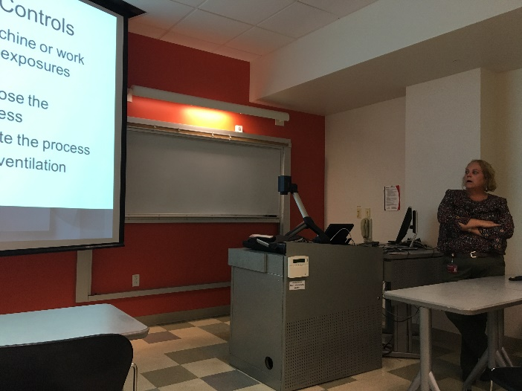
Ms. Elsbern started her training by letting RET participants know that OSHA Hazard Communication Standards have recently been revised in order to align to a global system (Figure 1). While these were revised in 2012, the transition is still taking place on campus. Ms. Elsbern then went over the training objectives which include a) recognizing routes of exposure, b) identifying proper chemical labeling techniques, c) disposing of chemical waste, and d) preventing and preparing for emergencies. Health concerns from working with chemicals were broken into two categories: acute and chronic. Ms. Elsbern reviewed the adverse health effects associated with each type of concern and expresses that the purpose of hazard communication efforts is to provide everyone their right to know what they will be exposed to during laboratory research. Some routes of exposure include inhalation, skin absorption, ingestion, and injection.
Figure 1. Ms. Elsbern Presenting to Participants.

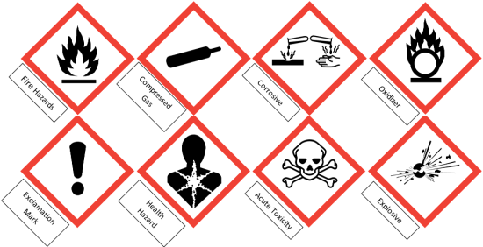
Hazard identification through Safety Data Sheets (SDS), previously known as Material Safety Data Sheets, was also a large focus of the training session. Ms. Elsbern expressed that even though we do not need to memorize the SDS for each chemical, we need to know where they are located and understand the hazards associated with each chemical we work with. Furthermore, if anyone in our laboratory were to be exposed to a hazardous chemical it is in part our responsibility to bring the SDS to the hospital in order for the proper treatment to be administered. It is also important for us to know the pictograms located on the outside of all chemicals (Figure 2). Recognizing these pictures is imperative to assessing hazards associated with chemicals before working with them during our research.
Figure 2. Standard Pictograms for Container Labels.

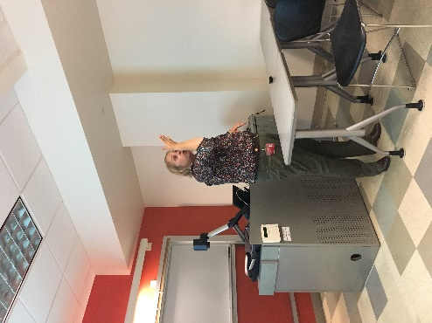
Other key topics discussed by Ms. Elsbern include proper labeling of chemicals. The general rule is when working with chemicals within your control, you are allowed to keep them unlabeled. Whenever you leave the chemical, however, you need to make sure it has a proper label. More importantly, hazardous chemicals need to be stored in a secondary container in case of a spill. When assessing the hazards associated with chemicals in a research lab, the Hazard Warning Diamond is a good point of reference. Tips for using a fume hood effectively, such as keeping the fume hood clean and not blocking ventilation, were then reviewed by Ms. Elsbern (Figure 3). This demonstration followed with an explanation on how to prevent emergency spills and how to dispose of toxic waste. Ms. Elsbern told all participants that the general rule is to ask our Principal Investigator (PI) before throwing away waste. After going over specifics about safety and health concerns in the laboratory, Ms. Elsbern asked participants to recognize the hazards and improper laboratory practices from several real-world laboratory pictures. The training concluded with Ms. Elsbern providing participants with website resources and her personal e-mail address to have on hand throughout the RET experience. The overall message to participants was to be proactive and diligent towards preventing emergencies when completing their summer research.
Figure 3. Ms. Elsbern Demonstrating How to Use a Fume Hood.

